SECTION 1: DOCUMENT BASED QUESTION

Ireland Topic 6
Government, economy and society in the Republic of Ireland, 1949 to 1989.

Case Study to which the documents relate :
The First Programme for Economic Expansion.

- In Document A what country is represented by figure X?
- What is the purpose of her visit to figure Y?
- According to document B how many foreign companies were established in the 1960s?
- According to document B what was the growth rate during the First Programme for Economic Expansion (20)
2.
- In your opinion which document would be of more use to the historian? Refer to both documents in your answer.
- Which document shows the greater optimism? Discuss with reference to both documents.
(20)

3.
- What are the strengths and weaknesses of documents such as Document A? Refer to the document in your answer.
- Would you consider Document B to be a biased source? Explain your answer.
(20)

4.
What impact did T.K. Whitaker’s First Programme for Economic Expansion have on the government policy of Sean Lemass?
(40)

- Document A -
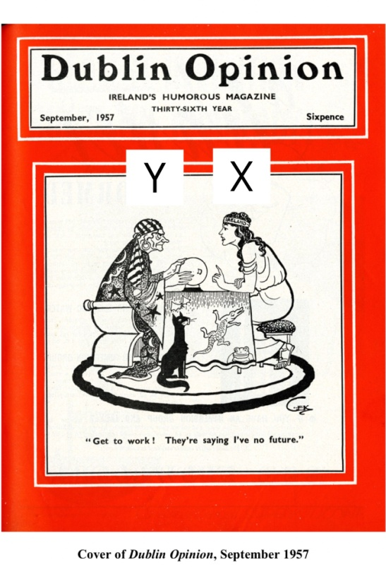

- Document B -

Lemass’s concrete achievements have been disputed. His reputation rests mainly on the policy signalled in the title of the famous report drawn up by the Secretary of the Finance Department, T.K. Whitaker, in 1958: Economic Development … … The distinctive feature of the policy he developed in the 1958 White Paper A Programme for Economic Expansion was the stimulation of industrial exports through the fostering of foreign investment.

In the 1960s this policy began to flower: over 350 new foreign companies were established in the decade. By 1974 foreign firms produced 40 per cent of manufacturing exports. The five years of the first Programme for Economic Expansion (1958-63) saw a growth rate of 4 per cent, and this continued through the Second Programme (1963-70) … In 1966 there was the first population growth to be recorded since the Famine … Overall, Ireland reached an epochal* moment. The point of intersection in the balance between agricultural and industrial workforce was crossed in the 1960s: in 1961 the balance was 379,000/257,000, in 1971 273,000/323,000.

*extremely important
Charles Townshend, Ireland. The 20th Century. Arnold (London), 1998, pp.171-2.

